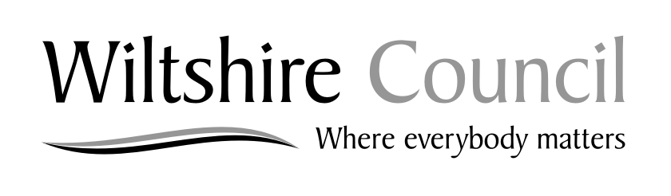

North Bradley Neighbourhood Development Plan
Consultation Response Form

Ref: (For official use only)

Please return to Wiltshire Council, by 5pm on Tuesday 17 September 2019.

By post to: Spatial Planning, Economic Development and Planning, Wiltshire Council, County Hall, Bythesea Road, Trowbridge, Wiltshire, BA14 8JN.

By e-mail to: neighbourhoodplanning@wiltshire.gov.uk

Via the council’s website at: http://consult.wiltshire.gov.uk/portal

This form has two parts:

Part A – Personal details
Part B – Your representation(s). Please use a separate sheet for each representation.

Part A – Personal details

*if an agent is appointed, please fill in your Title, Name and Organisation but the full contact details of the agent must be completed.

 | 1. Personal details | 2. Agent’s details (if applicable)*
Title

First name

Last name

Job title
(where relevant)
Organisation
(where relevant)
Address Line 1

Address Line 2

Address Line 3

Address Line 4

Postcode

Telephone Number

Email Address

Part B – Please use a separate sheet for each part of the plan you wish to comment on

To which part of the North Bradley Neighbourhood Development Plan do your comments relate?

Page: Paragraph: Other:

Comment:

Continue on a separate sheet if necessary

Future notification

I wish to be notified of the decision on the

North Bradley Neighbourhood Development Plan: YES: NO:

Signature: Date:

Thank you for completing this form.

Data Protection

Wiltshire Council has a duty to protect personal information and will process personal data in accordance with Data Protection legislation. The personal data you provide on this form will only be used for the purpose of the Wiltshire Development Framework. It may also be used for the prevention or detection of fraud or crime and in an anonymised form for statistical purposes. The data will be stored on computer and/or manual files. You have a right to a copy of your information held by any organisation, with some exemptions. To gain access to your personal data held by Wiltshire Council or if you have any Data Protection concerns please contact Wiltshire Council’s Data Protection Officer on 01225 713000 (switchboard) or e-mail to dataprotection@wiltshire.gov.uk .”

